**< User Guide for iss-vm >**

**Installation steps:**

1. Download and install Virtualbox software: <https://www.virtualbox.org/wiki/Downloads>
2. Download iss-vm virtual machine (an Appliance) from:

( part 1 about 11 GB in file size )

<http://bit.ly/iss-vm-v17a>

( part 2 about 10 GB in file size )

<http://bit.ly/iss-vm-v17b>

**[Note] Please check/ensure the 'virtualization' option is enabled in your computer's BIOS/hardware (Google it if not sure)**

1. Start Virtualbox software
2. Click File 🡪 Import Appliance

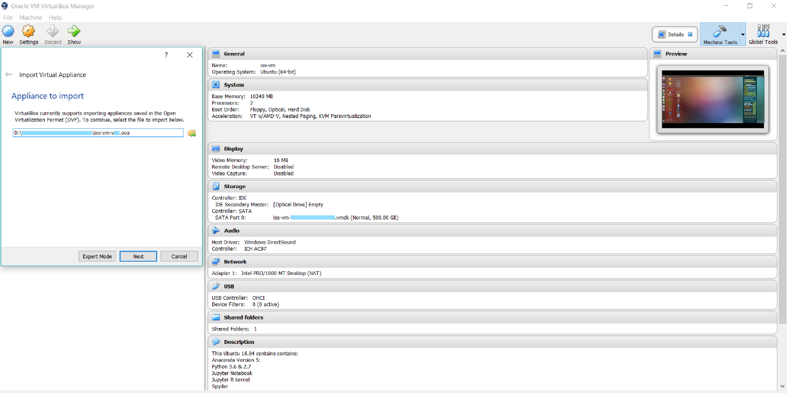

1. Click Start to use iss-vm
2. Most data science software are on the desktop

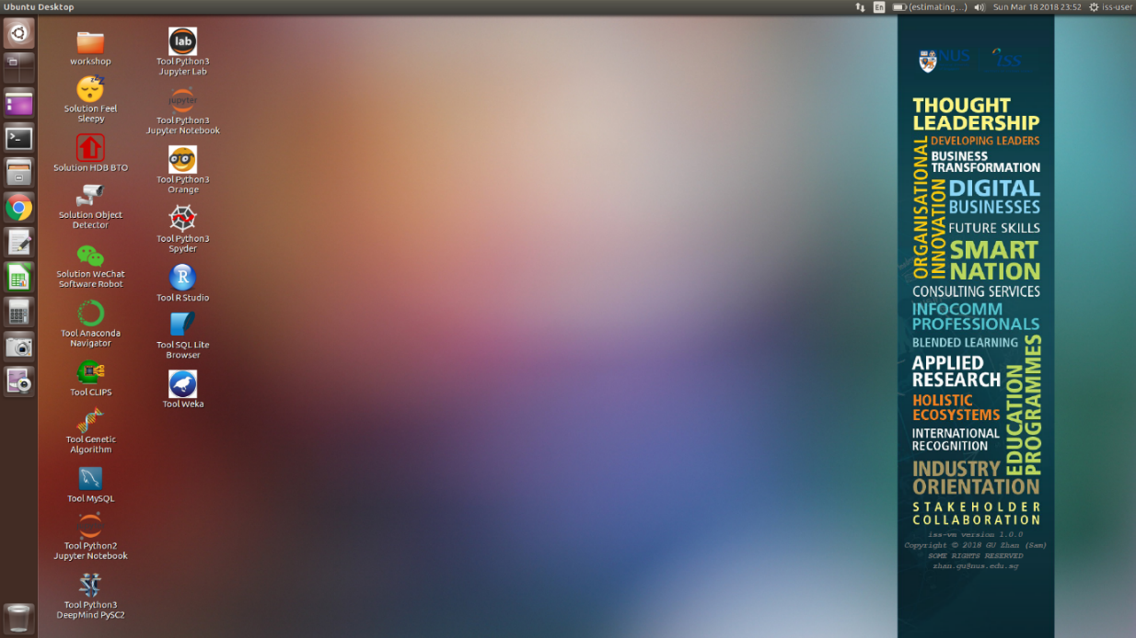

**This iss-vm Ubuntu 16.04 contains contains:**

Anaconda-Linux-x86_64

Python 3.6 in conda environment: iss-env-py3

Python 2.7 in conda environment: iss-env-py2

Jupyter Notebook

Jupyter R kernel

Spyder

Orange

scikit-learn

tensorflow

pytorch

keras

conda

pip

nltk & nltk data : nltk.download('popular')

R

R Studio

R Rattle

CLIPS (Rule Based Expert System)

Git (Git Bash)

Solver (Nonlinear Programming / Genetic Algorithms) for LibreOffice

MySQL

Google Cloud SDK: gcloud & datalab

Google APIs Client Library for Python: google-api-python-client

Weka

DeepMind PySC2 - StarCraft II Learning Environment

ROS Kinetic

MongoDB Node.js npm

TagUI

spaCy

Orange3-Associate

Docker

JBoss KIE 7.12

Eclipse IDE

Maven

durable-rules

Redis

casperjs (and phantomjs) on ubuntu

pip install face_recognition

Sikuli: visual recognition to automate desktop applications

wmctrl

xdotool

tensorflow 1.11

Robotic Operating System (ROS) Kinetic

linux machine name : iss-vm

linux user id : iss-user

linux user password : iss-user

anaconda python 3 environment : iss-env-py3

anaconda python 2 environment : iss-env-py2

MySQL user id : iss-user

MySQL user password : iss-user

MySQL root user id : root

MySQL root user password : iss-user

VirtualBox shared folder in guest (iss-vm linux) operating system:

/media/sf_vm_shared_folder

VirtualBox shared folder in host operating system:

D:\0020_vm_disk\vm_shared_folder

Copyright © 2018 GU Zhan (Sam)

SOME RIGHTS RESERVED

[zhan.gu@nus.edu.sg](mailto:zhan.gu@nus.edu.sg)

This iss-vm is free for personal usage. Please write to us for commercial usage enquiry.